**AIM: Implementation of searching algorithms: Linear Search and Binary search**

1. **Linear Search:**

**THEORY:**

Linear search is the simplest searching algorithm that searches for an element in a list in sequential order. We start at one end and check every element until the desired element is not found. Here is simple approach is to do Linear Search:

• Start from the leftmost element of array and one by one compare the element we are searching for with each element of the array.

• If there is a match between the element we are searching for and an element of the array, return the index.

• If there is no match between the element we are searching for and an element of the array, return -1.

**Linear Search Complexities:**

**Time Complexity:** O(n)

**Space Complexity:** O(1)

**Linear Search Applications:**

For searching operations in smaller arrays (<100 items).

**Algorithm:**

Linear Search ( Array A, Value x)

Step 1: Set i to 1

Step 2: if i > n then go to step 7

Step 3: if A[i] = x then go to step 6

Step 4: Set i to i + 1

Step 5: Go to Step 2

Step 6: Print Element x Found at index i and go to step 8

Step 7: Print element not found

Step 8: Exit

**Pseudocode:**

procedure linear_search (list, value)

for each item in the list

if match item == value

return the item's location

end if

end for

end procedure

**Example:**

The following steps are followed to search for an element k = 1 in the list below.

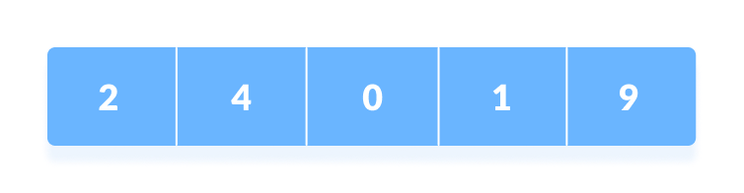Array to be searched for

1. Start from the first element, compare k with each element x.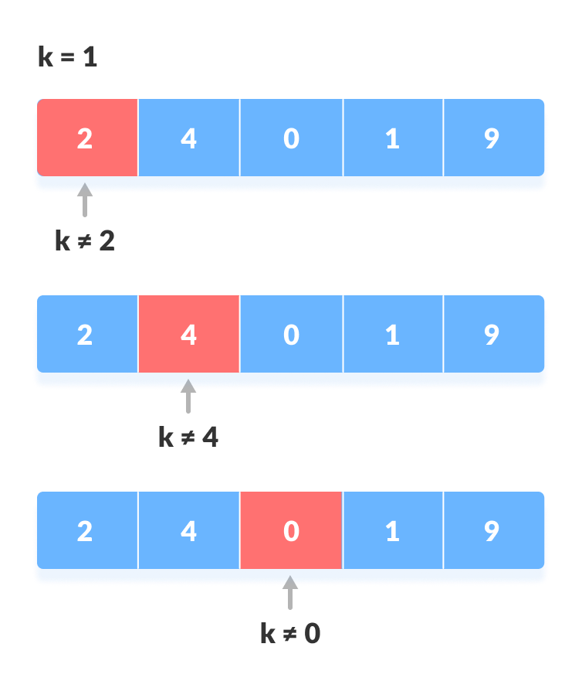Compare with each element
2. If x == k, return the index.

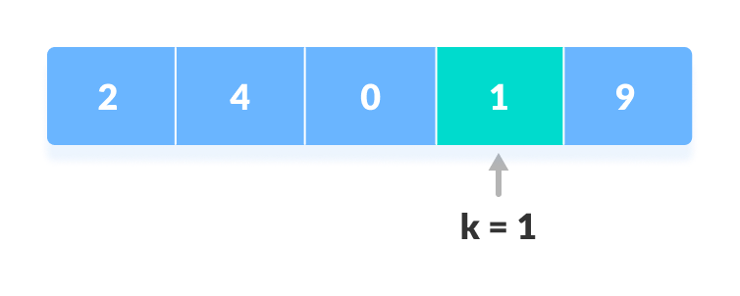Element found

1. Else, return not found.

**SOURCE CODE:**

#include <iostream>

using namespace std;

int linear_search( int arr[], int n, int s )

{

for(int i=0; i < n; i++)

{

if(arr[i] == s)

{

return i;

}

}

return -1;

}

int main()

{

int n;

cout << "Enter number of elements for an array \n";

cin >> n;

int arr[n];

for (int i = 0; i < n; i++)

{

cout << "Enter element "<<i+1<<"\n";

cin >> arr[i];

}

int s;

cout<< "Enter element to search \n";

cin>>s;

int rs = linear_search(arr, n, s);

if(rs==-1)

{

cout<<"Element is not found!!";

}

else

{

cout<<"Element is found at position "<<rs+1;

}

return 0;

}

**OUTPUT:**

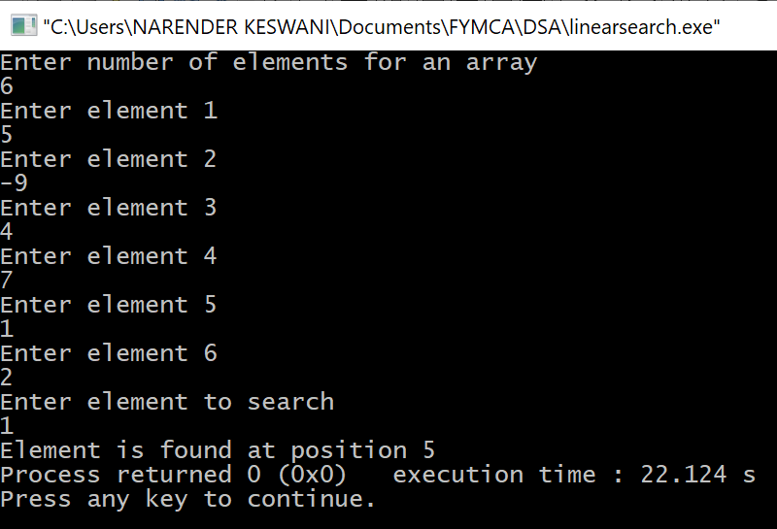

1. **Binary Search:**

**THEORY:**

Binary Search is a searching algorithm for finding an element's position in a sorted array. The element is always searched in the middle of a portion of an array. Binary search can be implemented only on a sorted list of items. If the elements are not sorted already, we need to sort them first. Binary Search Algorithm can be implemented in two ways:

1. Iterative Method
2. Recursive Method

**Time Complexities:**

* **Best case complexity: O(1)**
* **Average case complexity: O(log n)**
* **Worst case complexity: O(log n)**

**Space Complexity: O(1).**

**Binary Search Applications:**

* **In libraries of Java, .Net, C++ STL, while debugging, the binary search is used to pinpoint the place where the error happens.**

**Binary Search Algorithm:**

1. **Iteration Method:**

do until the pointers low and high meet each other.

mid = (low + high)/2

if (x == arr[mid])

return mid

else if (x > arr[mid]) // x is on the right side

low = mid + 1

else // x is on the left side

high = mid – 1

1. **Recursive Method:**

binarySearch(arr, x, low, high)

if low > high

return False

else

mid = (low + high) / 2

if x == arr[mid]

return mid

else if x > arr[mid] // x is on the right side

return binarySearch(arr, x, mid + 1, high)

else // x is on the right side

return binarySearch(arr, x, low, mid - 1)

**Example:**

The array in which searching is to be performed is: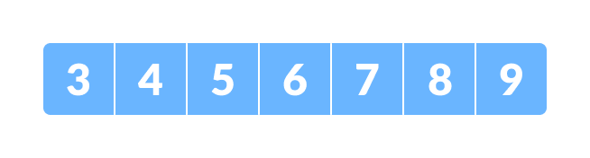

Initial array  
Let x = 4 be the element to be searched.

Set two pointers low and high at the lowest and the highest positions respectively.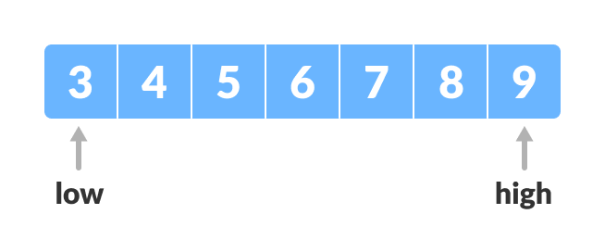

Setting pointers

Find the middle element mid of the array ie. arr[(low + high)/2] = 6.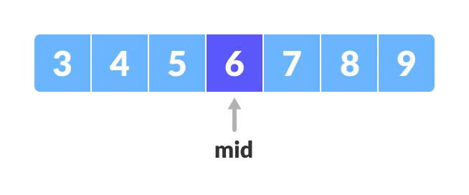

Mid element

If x == mid, then return mid.Else, compare the element to be searched with m.

If x > mid, compare x with the middle element of the elements on the right side of mid. This is done by setting low to low = mid + 1.

Else, compare x with the middle element of the elements on the left side of mid. This is done by setting high to high = mid - 1.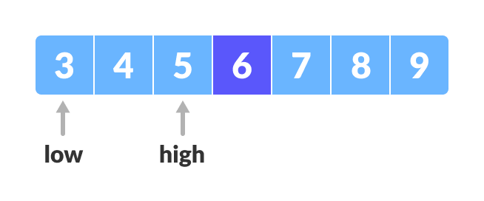

Finding mid element

Repeat steps 3 to 6 until low meets high.

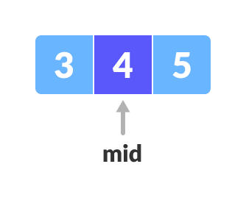

Mid element

x = 4 is found.

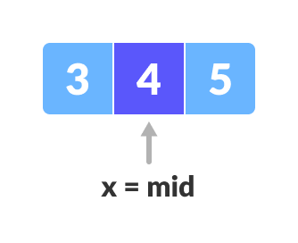

Founded

**SOURCE CODE:**

#include <iostream>

using namespace std;

void printArray(int arr[], int size)

{

int i;

for (i=0; i < size; i++)

cout << arr[i] << " ";

cout << endl;

}

int binary_search( int arr[], int l, int r, int s )

{

if (r>=1)

{

int mid = (l + r)/2;

if(arr[mid] == s)

{

return mid;

}

else if(arr[mid] < s)

{

return binary_search(arr, mid + 1, r, s);

}

else

{

return binary_search(arr, l, mid - 1, s);

}

}

else

{

return -1;

}

}

int * bubble_sort( int A[ ], int n )

{

int temp;

for(int k = 0; k< n-1; k++)

{

// (n-k-1) is for ignoring comparisons of elements which have already been compared in earlier iterations

for(int i = 0; i < n-k-1; i++)

{

if(A[ i ] > A[ i+1] )

{

// here swapping of positions is being done.

temp = A[ i ];

A[ i ] = A[ i+1 ];

A[ i + 1] = temp;

}

}

}

return A;

}

int main()

{

int n;

cout << "Enter number of elements for an array \n";

cin >> n;

int arr[n];

for (int i = 0; i < n; i++)

{

cout << "Enter element "<<i+1<<"\n";

cin >> arr[i];

}

int s;

cout<< "Enter element to search \n";

cin>>s;

int *ar = bubble_sort(arr,n);

cout<< "Sorted array is \n";

printArray(ar,n);

int rs = binary_search(ar, 0, n-1, s);

if(rs==-1)

{

cout<<"Element is not found!!";

}

else

{

cout<<"Element is found at position "<<rs+1;

}

return 0;

}

**OUTPUT:**

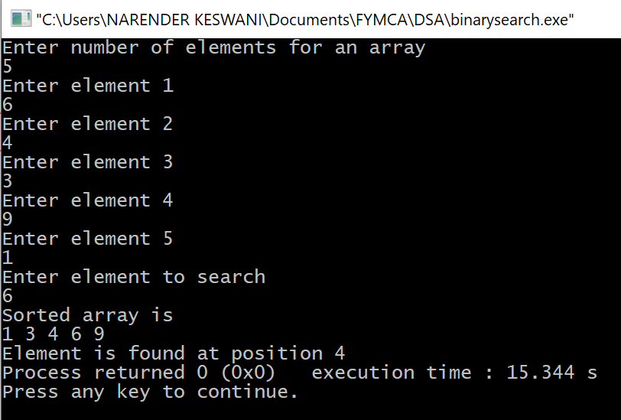

**CONCLUSION:**

I have learned the searching algorithms such as linear and binary. It is observed that binary search is more optimized than linear search.